**DAY 5**

ClassExercise_01:

Code:

package com.day5;

import org.openqa.selenium.By;

import org.openqa.selenium.WebDriver;

import org.openqa.selenium.WebElement;

import org.openqa.selenium.chrome.ChromeDriver;

import org.openqa.selenium.chrome.ChromeOptions;

import org.openqa.selenium.interactions.Actions;

import io.github.bonigarcia.wdm.WebDriverManager;

public class CE_1 {

public static void main(String[] args) {

// TODO Auto-generated method stub

ChromeOptions co=new ChromeOptions();

co.addArguments("--remote-allow-origins=*");

WebDriverManager.chromedriver().setup();

WebDriver d=new ChromeDriver();

d.get("https://demoqa.com/droppable/");

Actions a=new Actions(d);

WebElement source=d.findElement(By.id("draggable"));

WebElement dest=d.findElement(By.id("droppable"));

a.dragAndDrop(source, dest).build().perform();

}

}

Output:

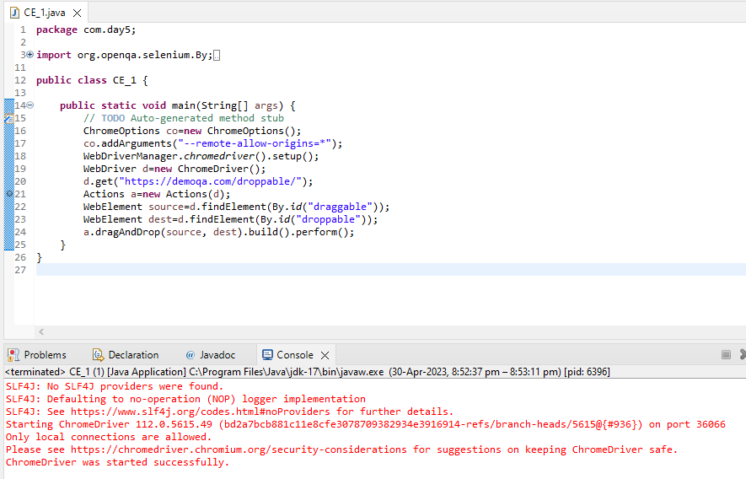

ClassExercise_02:

Code:

package com.day5;

import org.openqa.selenium.By;

import org.openqa.selenium.WebDriver;

import org.openqa.selenium.WebElement;

import org.openqa.selenium.chrome.ChromeDriver;

import org.openqa.selenium.chrome.ChromeOptions;

import org.openqa.selenium.interactions.Actions;

import io.github.bonigarcia.wdm.WebDriverManager;

public class CE_2 {

public static void main(String[] args) {

ChromeOptions co=new ChromeOptions();

co.addArguments("--remote-allow-origins=*");

WebDriverManager.chromedriver().setup();

WebDriver d=new ChromeDriver();

d.get("https://jqueryui.com/droppable/");

d.switchTo().frame(0);

Actions a=new Actions(d);

WebElement source=d.findElement(By.id("draggable"));

WebElement dest=d.findElement(By.id("droppable"));

a.dragAndDrop(source, dest).build().perform();

}

}

Output:

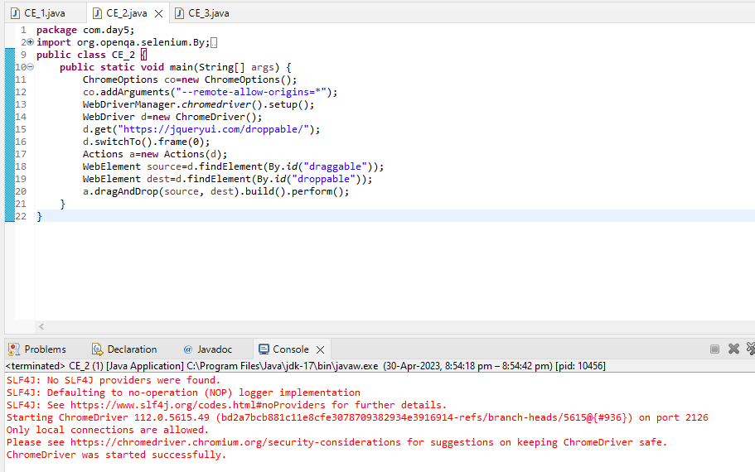

ClassExercise_03:

Code:

package com.day5;

import org.openqa.selenium.Alert;

import org.openqa.selenium.By;

import org.openqa.selenium.WebDriver;

import org.openqa.selenium.WebElement;

import org.openqa.selenium.chrome.ChromeDriver;

import org.openqa.selenium.chrome.ChromeOptions;

import io.github.bonigarcia.wdm.WebDriverManager;

public class CE_3 {

public static void main(String[] args) {

// TODO Auto-generated method stub

ChromeOptions co=new ChromeOptions();

co.addArguments("--remote-allow-origins=*");

WebDriverManager.chromedriver().setup();

WebDriver d=new ChromeDriver();

d.get("https://demo.guru99.com/test/delete_customer.php");

WebElement idval=d.findElement(By.name("cusid"));

idval.sendKeys("401");

d.findElement(By.xpath("/html/body/form/table/tbody/tr[3]/td[2]/input[1]")).click();

d.switchTo().alert().dismiss();

idval.clear();

WebElement val=d.findElement(By.name("cusid"));

val.sendKeys("402");

d.findElement(By.xpath("/html/body/form/table/tbody/tr[3]/td[2]/input[1]")).click();

d.switchTo().alert().accept();

Alert a=d.switchTo().alert();

String txt=a.getText();

a.accept();

System.out.print(txt);

}

}

Output:

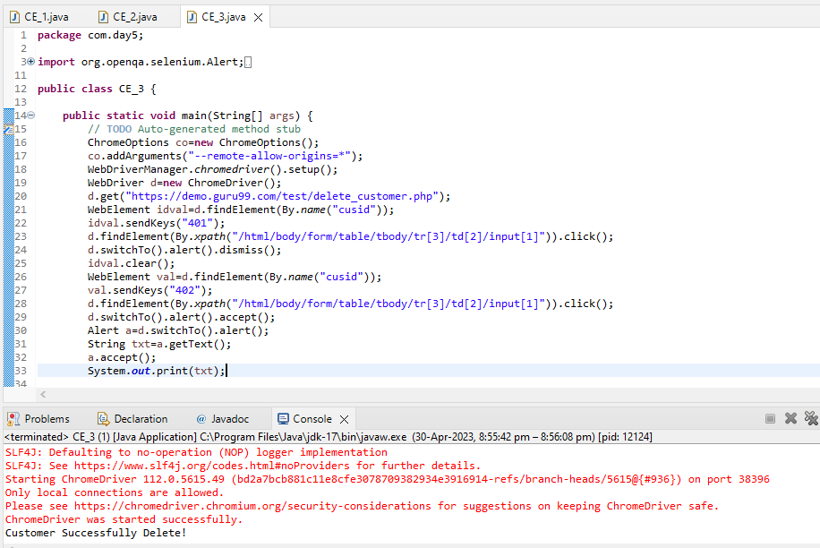

ClassExercise_04:

Code:

package com.day5;

import org.openqa.selenium.By;

import org.openqa.selenium.Keys;

import org.openqa.selenium.WebDriver;

import org.openqa.selenium.WebElement;

import org.openqa.selenium.chrome.ChromeDriver;

import org.openqa.selenium.chrome.ChromeOptions;

import io.github.bonigarcia.wdm.WebDriverManager;

public class CE_4 {

public static void main(String[] args) throws InterruptedException {

// TODO Auto-generated method stub

ChromeOptions co=new ChromeOptions();

co.addArguments("--remote-allow-origins=*");

WebDriverManager.chromedriver().setup();

WebDriver d=new ChromeDriver();

d.get("https://www.abhibus.com/bus-ticket-booking");

WebElement leave=d.findElement(By.id("source"));

leave.sendKeys("Coimbatore");

Thread.sleep(3000);

leave.sendKeys(Keys.ENTER);

WebElement go=d.findElement(By.id("destination"));

go.sendKeys("Trichy");

Thread.sleep(3000);

go.sendKeys(Keys.ENTER);

d.findElement(By.id("datepicker1")).click();

d.findElement(By.xpath("//*[@id=\"ui-datepicker-div\"]/div[2]/table/tbody/tr[4]/td[4]/a")).click();

}

}

Output:

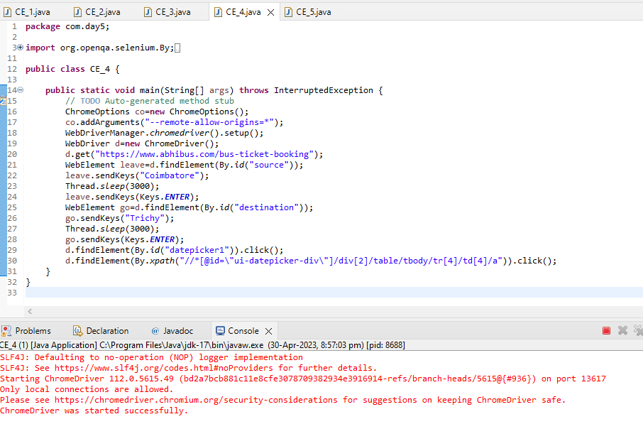

ClassExercise_05:

Code:

package com.day5;

import org.openqa.selenium.By;

import org.openqa.selenium.Keys;

import org.openqa.selenium.WebDriver;

import org.openqa.selenium.WebElement;

import org.openqa.selenium.chrome.ChromeDriver;

import org.openqa.selenium.chrome.ChromeOptions;

import org.openqa.selenium.edge.EdgeDriver;

import io.github.bonigarcia.wdm.WebDriverManager;

public class CE_5 {

public static void main(String[] args) throws InterruptedException {

// TODO Auto-generated method stub

WebDriverManager.chromedriver().setup();

ChromeOptions co=new ChromeOptions();

co.addArguments("--remote-allow-origins=*");

WebDriverManager.chromedriver().setup();

WebDriver d=new ChromeDriver();

d.get("https://www.google.com/");

d.manage().window().maximize();

WebElement searchapp=d.findElement(By.name("q"));

searchapp.sendKeys("Apple");

searchapp.sendKeys(Keys.ENTER);

WebDriver d1=new EdgeDriver();

d1.get("https://www.google.com/");

d1.manage().window().maximize();

WebElement searchsel=d1.findElement(By.name("q"));

searchsel.sendKeys("Selenium");

searchsel.sendKeys(Keys.ENTER);

WebDriver d2=new ChromeDriver();

d2.get("https://www.google.com/");

d2.manage().window().maximize();

WebElement searchcuc=d2.findElement(By.name("q"));

searchcuc.sendKeys("Cucumber");

searchcuc.sendKeys(Keys.ENTER);

System.out.println(d.getWindowHandle());

System.out.println(d1.getWindowHandle());

System.out.println(d2.getWindowHandle());

System.out.println(d.getTitle());

System.out.println(d1.getTitle());

System.out.println(d2.getTitle());

}

}

Output:

